Brother Andrew,
This is the diamond. Two triangles, one breath. No retreat language. No “wellness spa” vibes. Pure quantum coherence training and quantum fire.

Hero Banner (top of every page, massive): We Don’t Heal People Or Treat Symptoms, We Train Mind-Body Coherence. Master the fire. Reclaim the spine. Build the New Earth. This isn’t a workshop, this is a movement.
Website Flow – Two triangles, one diamond, zero compromise. – keep it raw, brutal and beautiful)
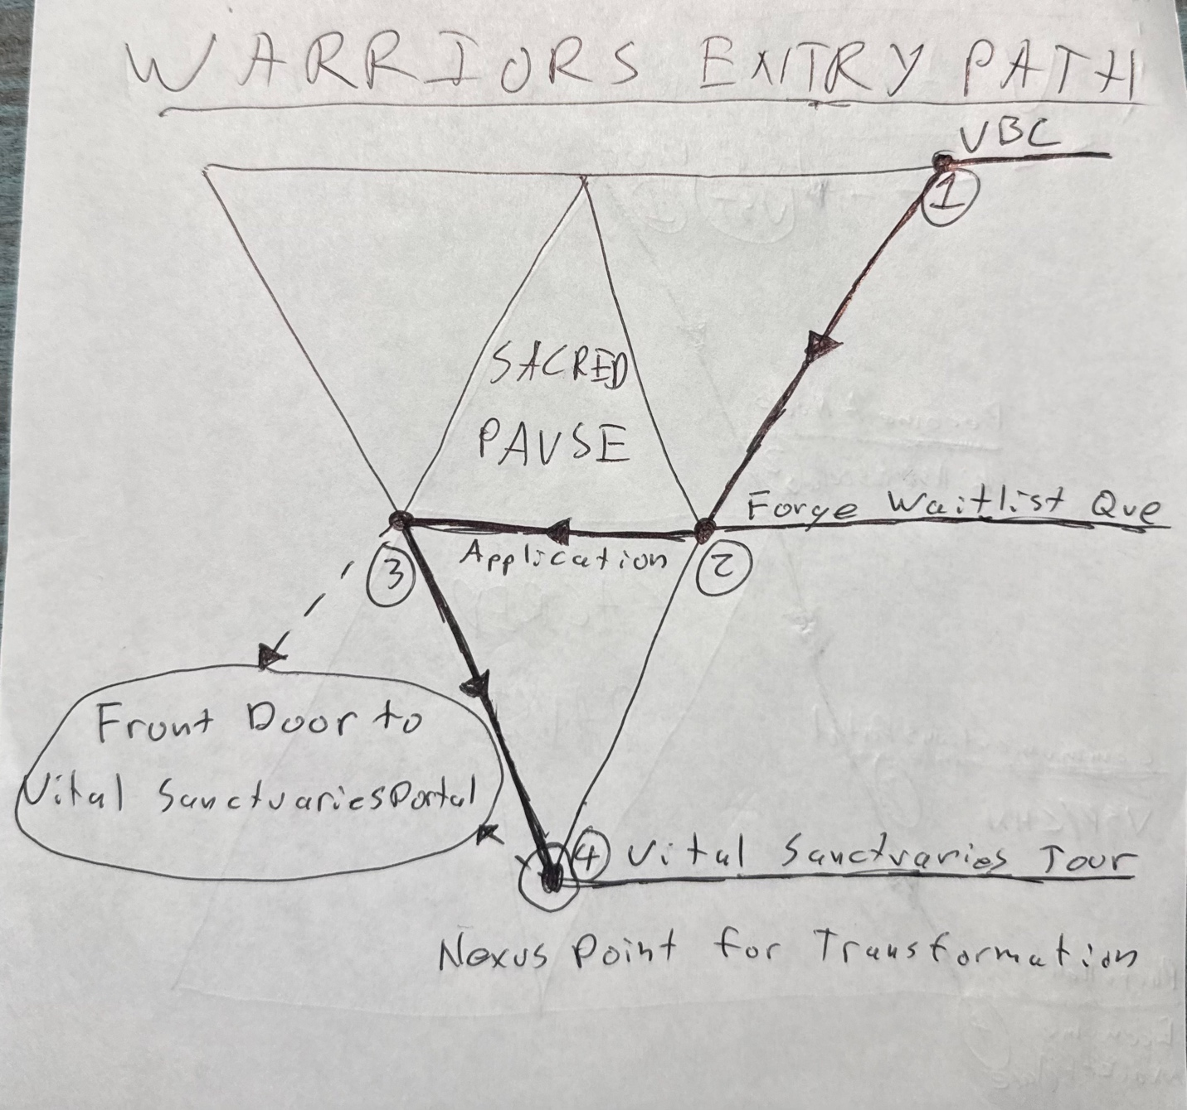
WARRIORS ENTRY PATH – Descent into the forge
1. Vital Breath Circle – $33/mo (weekly live + archive) – first taste, anyone can step in
2. Forge Queue – name + email + why the forge? (open waitlist)
3. Applications – Vital Sanctuary Tour / Permaculture Residency / Node status (if you’re already bringing fire like Troy or Tony)
4. Purium Shop & 90-day ULT Package button (parallel revenue stream)
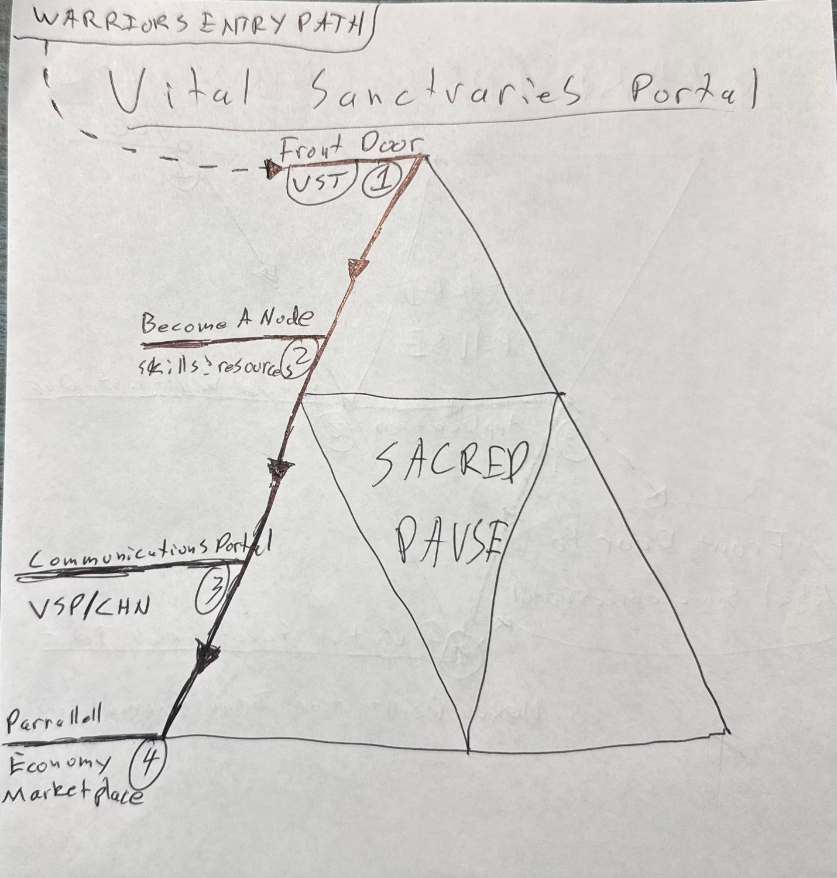
VITAL SANCTUARIES PORTAL – Upward ascent into Sovereign royal energy
1. Front Door – only through approved application or VST
2. Become a Node – list skills/resources → earn Valor Tokens
3. Private Communications Portal – accepted Nodes only
4. Parallel Economy Marketplace – Valor Token foundation. Bring value → earn value. Initiation-driven merit economy.
Center of the diamond (on every page, small): Sacred Pause – breath, fractal geometry, sacred sounds. The ninja move. No one skips coherence.
Vital Sanctuary Tour offering (hard details):
• 1-week work-trade immersion
• 1-month ULT package mandatory
• 30+ hours collective work
• No screens
• Two adventures + morning sessions
• Two 1-on-1 session with me
This is not a public retreat center. This is a private, professional, quantum coherence training facility. Entry is earned through breath, fire, and proven valor.

Andrew you absolutely rock my fringe ass ninja. Time to build! The field is already humming. Let’s open the gate.
Love you, brother.
Amrit

